* SQL queries to generate table and create relations(total of 13 table were used)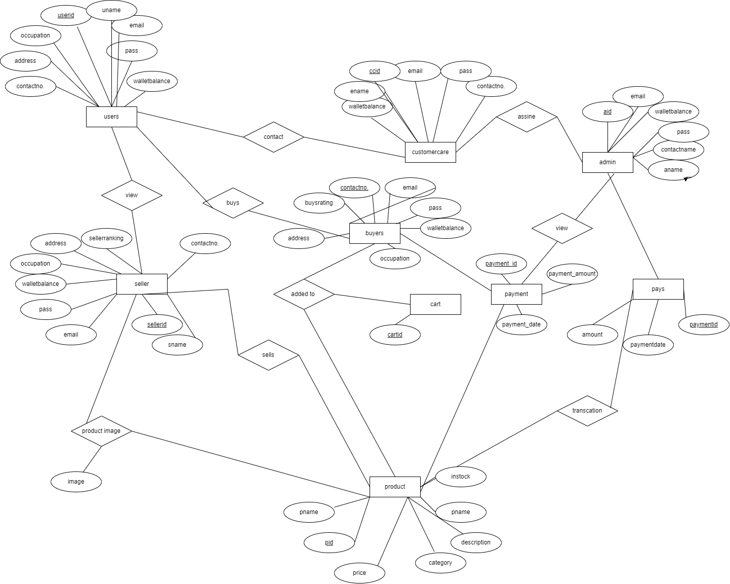

CREATE DATABASE shopify;

USE shopify;

create table customercare(

ccid varchar(20),

ename varchar(50) unique,

walletBalance real default 0,

email varchar(30),

pass varchar(100),

contactNo bigint,

primary key(ccid)

);

create table admin(

aid varchar(20),

email varchar(30) unique,

walletBalance real default 0,

pass varchar(100),

aname varchar(50),

contactNo bigint,

primary key(aid)

);

create table users(

userid varchar(20),

uname varchar(50),

email varchar(30) unique,

pass varchar(100),

walletBalance real default 0,

occupation varchar(20),

address varchar(100),

contactNo bigint,

primary key(userid)

);

create table seller(

sellerID varchar(20),

sname varchar(50),

email varchar(30) unique,

pass varchar(100),

walletBalance real default 0,

occupation varchar(20),

address varchar(100),

sellerRating real,

contactNo bigint,

primary key(sellerID),

foreign key(sellerID) references users(userid) on delete cascade on update cascade

);

create table buyer(

buyerID varchar(20),

bname varchar(50),

email varchar(30) unique,

pass varchar(100),

walletBalance real default 0,

occupation varchar(20),

address varchar(100),

buyerRating real,

contactNo bigint,

primary key(buyerID),

foreign key(buyerID)references users(userid) on delete cascade on update cascade

);

create table cart(

cartID int auto_increment,

buyerID varchar(20) unique,

primary key(cartID),

foreign key(buyerid)references buyer(buyerID) on delete cascade on update cascade

);

create table product(

sellerID varchar(20) not null,

pid varchar(20) not null unique,

pname varchar(100),

price real,

category varchar(50),

description varchar(255),

primary key(pid),

inStock bit,

foreign key(sellerid)references seller(sellerID) on delete cascade on update cascade

);

create TABLE productImages(

sellerID varchar(20) not null,

pid varchar(20) not null,

imageNo int,

imageLocation varchar(255),

foreign key(sellerid)references seller(sellerID) on delete cascade on update cascade,

foreign key(pid)references product(pid) on delete cascade on update cascade

);

create table contacts(

ccid varchar(20),

userid varchar(20),

primary key(ccid,userid),

foreign key(ccid)references customercare(ccid) on delete cascade on update cascade,

foreign key(userid)references users(userid) on delete cascade on update cascade

);

create table assigns(

aid varchar(20),

ccid varchar(20),

primary key(aid,ccid),

foreign key(aid) references admin(aid) on delete cascade on update cascade,

foreign key(ccid) references customercare(ccid) on delete cascade on update cascade

);

create table payment(

buyerID varchar(20),

pid varchar(20),

aid varchar(20),

paymentamount real,

paymentDate datetime default CURRENT_TIMESTAMP,

paymentID int auto_increment,

primary key(paymentID),

foreign key(buyerID) references buyer(buyerID) on delete cascade on update cascade,

foreign key(pid) references product(pid) on delete cascade on update cascade,

foreign key(aid) references admin(aid) on delete cascade on update cascade

);

create table pays(

aid varchar(20),

sellerID varchar(20),

pid varchar(20),

amount real,

paymentDate datetime default CURRENT_TIMESTAMP,

PaymentID int auto_increment,

primary key(PaymentID),

foreign key(aid) references admin(aid) on delete cascade on update cascade,

foreign key(sellerID) references seller(sellerID) on delete cascade on update cascade,

foreign key(pid) references product(pid) on delete cascade on update cascade

);

create table addedTo(

pid varchar(20),

buyerID varchar(20),

primary key(pid,buyerID),

foreign key(pid) references product(pid) on delete cascade on update cascade,

foreign key(buyerID) references buyer(buyerID) on delete cascade on update cascade

);

|  |
| --- |
| CREATE USER 'ayush'@'localhost' IDENTIFIED BY 'kumar';  GRANT ALL PRIVILEGES ON shopify.* to ‘ayush’@’localhost’; |
|  |  |

* Populating table using queries

INSERT INTO `customercare`(`ccid`, `ename`, `email`, `pass`, `contactNo`) VALUES ('212123037','puspa','kumawat’,'puspa123',7404246173);

INSERT INTO `customercare`(`ccid`, `ename`, `email`, `pass`, `contactNo`) VALUES ('202123046','prajay','boldane','prajay123',7408301428);

INSERT INTO `customercare`(`ccid`, `email`, `pass`) VALUES ('2','2','2');

INSERT INTO `buyer`(`buyerID`, `email`, `pass`) VALUES ('212123038','prasad123@gmail.com','Prasad123@');

INSERT INTO `seller`(`sellerID`, `email`, `pass`) VALUES ('212123033','Monu123@gmail.com','Monu123@');

